|  |  |  |
| --- | --- | --- |
|  | **GUJARAT TECHNOLOGICAL UNIVERSITY**  Chandkheda, Ahmedabad  Affiliated |  |

SardarVallabhbhai Patel

Institute Of Technology

Vasad-041

A

Project Report

On

**Food Scanner**

Under the course of

**DESIGN ENGINEERING – 1A (2130005)**

B. E. II, Semester – III

**(Information Technology)**

***Submitted by:***

Group ID:5301

|  |  |  |
| --- | --- | --- |
| **Sr.** | **Name of student** | **Enrolment No.** |
|  |  |  |
| 1 | Wade Kaustubh | 160410116050 |
| 2 | Kothari Naisargi | 160410116051 |
| 3 | Munshi Parjita | 160410116064 |
|  |  |  |
|  |  |  |

|  |  |
| --- | --- |
| **Prof.**  **Amit Kariyani**  **(Faculty Guide)** | **Prof.**  **N.V. Shah**  **(Head Of Department)** |

**Academic year**

**(2017-2018)**

|  |  |  |
| --- | --- | --- |
|  | **GUJARAT TECHNOLOGICAL UNIVERSITY**  Chandkheda, Ahmedabad  Affiliated |  |

**CERTIFICATE**

This is to certify that the students namely, **Kaustubh Wade(160410116050), Naisargi Kothari(160410116051),Parjita Munshi(160410116064)** of

***B. E. (Information Technology) Semester III*** have successfully completed the course work and related tasks for the course of **Design Engineering 1A (2130005)** during the academic term ending in the month of October 2017.

Date of submission: 13-10-2017

Place: SVIT VASAD

**Prof. Mr. Amit Kariyani Prof. Mrs.N.V.Shah**

Head of the Department

**(Faculty in charge) (Internal Examiner) (External Examiner)**

**FOOD SCANNER**

**Contents:**

* 1.Introduction
* 2.AEIOU Canvas
* 3.Empathy Canvas
* 4.Ideation Canvas
* 5.Production Development Canvas
* 6.Mind Mapping

**1.INTRODUCTION**

Now a day we observe the many food related health problems increases day by day due to increasing in food quality issues.We rarely find healthy, hygieneand pure food.

When we go outside the country we did not know about the exact food items used in dishes. And sometimes we clearly unable to recognize some food.

So, consider this all food related issues we work on it and decide to develop basic food scanner which can scan your food to deliver accurate information.

**2. AEIOU CANVAS**

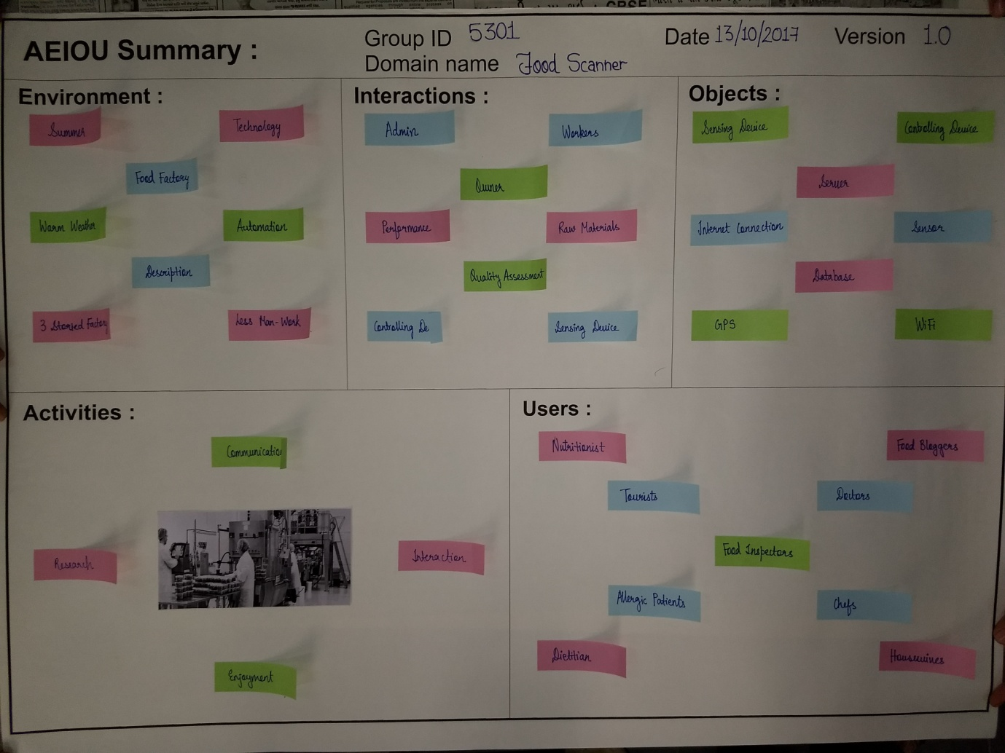

We discuss here some points which are covered in this canvas.

**ACTIVITY:**

* When we visited in food laboratory we communicate with managers and workers include every staff member and try to know about their work and how food proceed in their laboratory.
* We saw that how they check food quality and how they differentiate food by their quality and then according to use they do process on that and used that food.
* We also saw all company workers engagement with their works.

**ENVIRONMENT:**

* Weather
* Technology used in food processing system
* Automation -all work done by machines and only one man handles with commuter that all machines
* Food Storage machines

**INTERACTIONS:**

At food factory we communicate with many people like.

* Admin
* Manager
* Workers

Work done by those peoples

* Raw materials checking
* Quality assessment
* Control the devices

**OBJECTS:**

Objects which are used in food sensor

* Sensing devices
* Controlling devices
* Connectors
* GPS
* Wi-Fi
* Internet connection
* Database

**USERS:**

Mostly food scanner used by these persons

* Food inspector
* Dietitian
* Chefs
* Doctors
* Food blogger

**3. EMPATHY MAPPING**

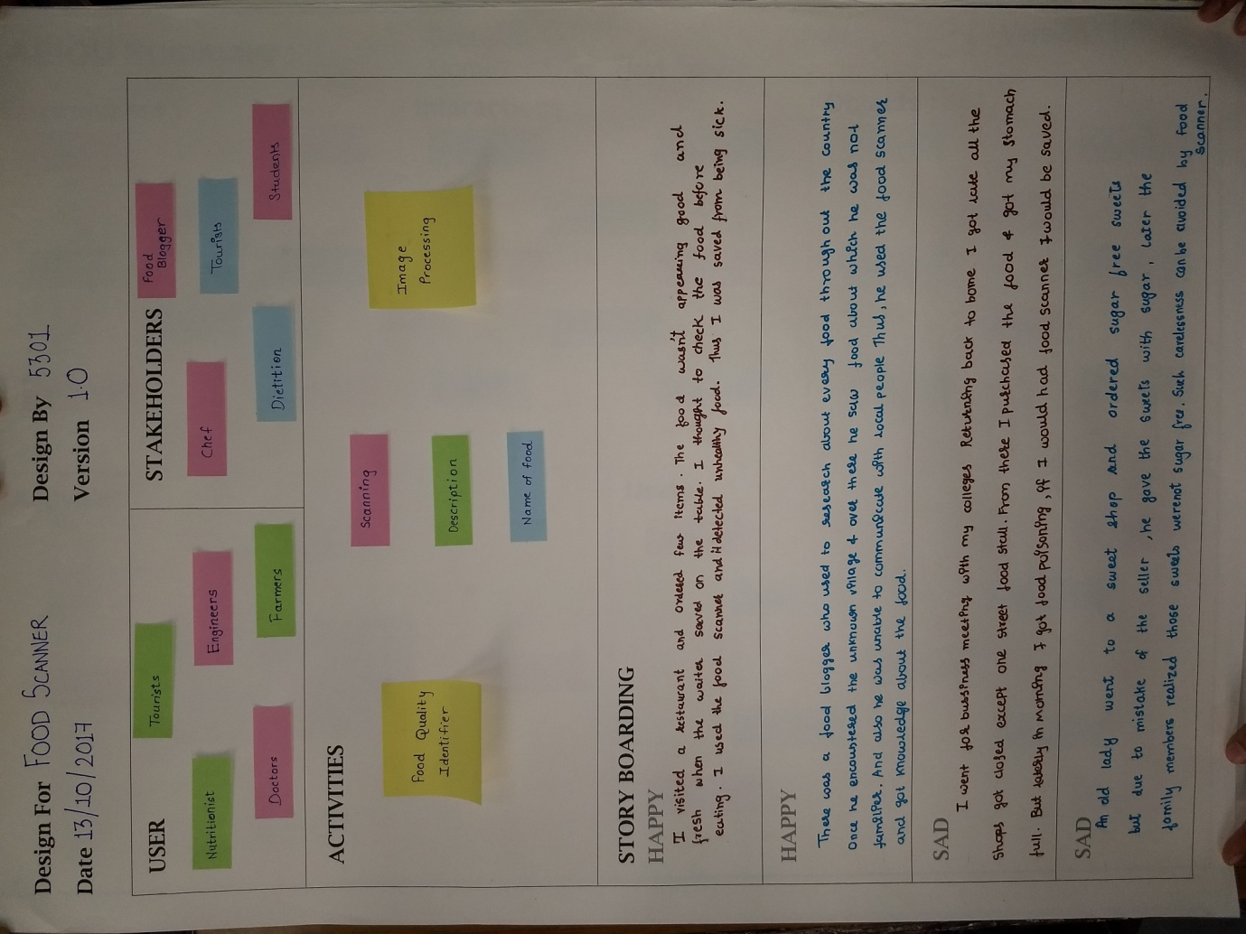

Here we are going to explain users, stack holders and activity. And here we are discussing about happy story and sad story which indicate how food scanner helps us.

**USERS:**

* Tourist
* Engineer
* Doctor
* Farmer

**STACKHOLDERS:**

* Chef
* Food blogger
* Student
* Dietitians

**ACTIVITY:**

* Food quality identifier
* Scanning
* Name of food
* Description
* Image processing

**4. IDEATION CANVAS**

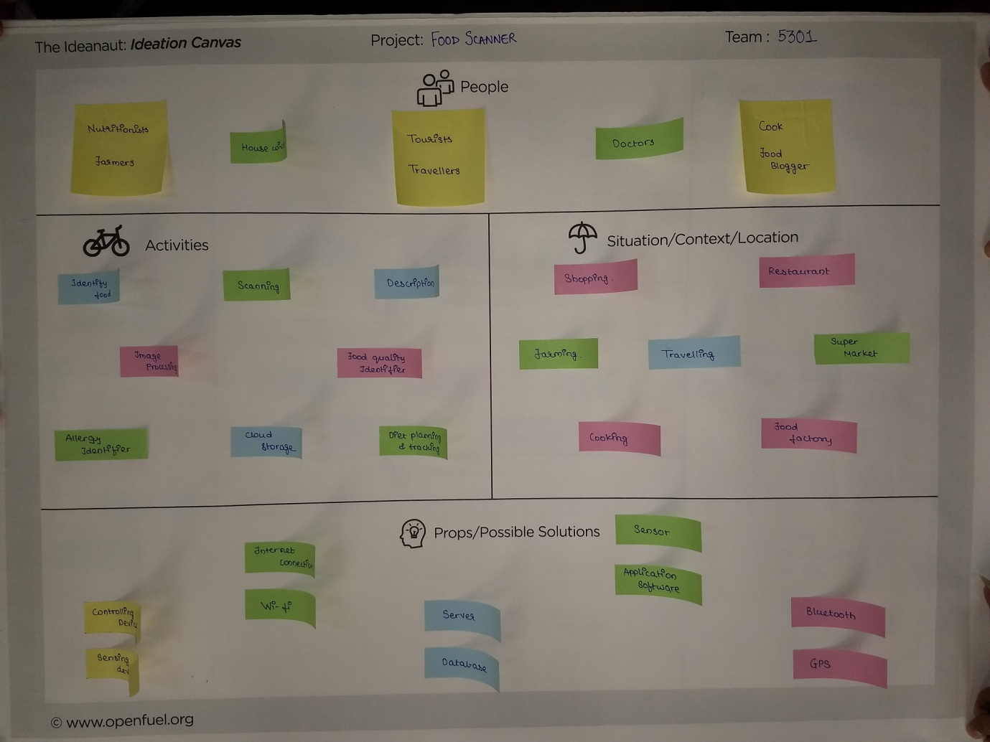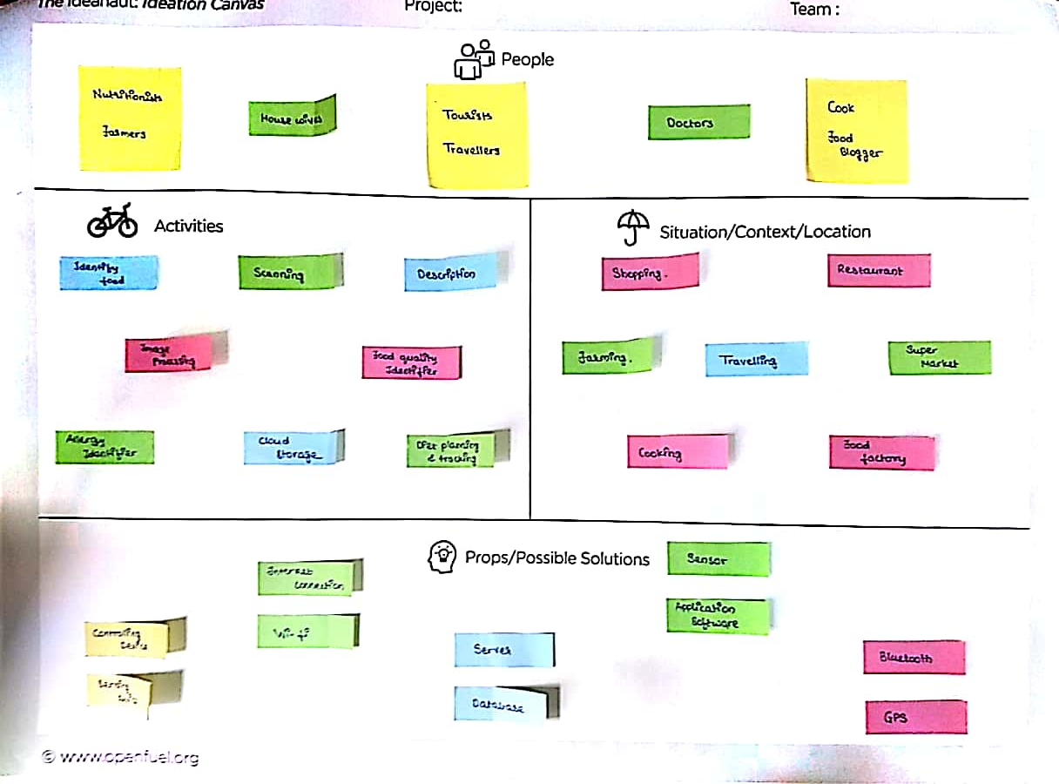

Here we are describing people, and activities of people, situation, location, and what types of problems face by peoples and their solution.

**PEOPLE:**

* Nutrition
* Tourist
* Traveler
* Doctor

**ACTIVITY:**

* Scanning
* Description
* Image processing
* Cloud storage
* Identity of food
* Food quality identifier
* Allergy identifier

**SITUATION/CONTEXT/LOCATION:**

* Shopping
* Farming
* Travelling
* Super market
* Restaurant
* Food factory
* Cooking

**PROPS/POSSIBLE SOLUTION:**

* Sensor
* Bluetooth
* GPS
* Application software
* Server
* Wi-Fi
* Database

**5. PRODUCT DEVLOPMENT CANVAS**

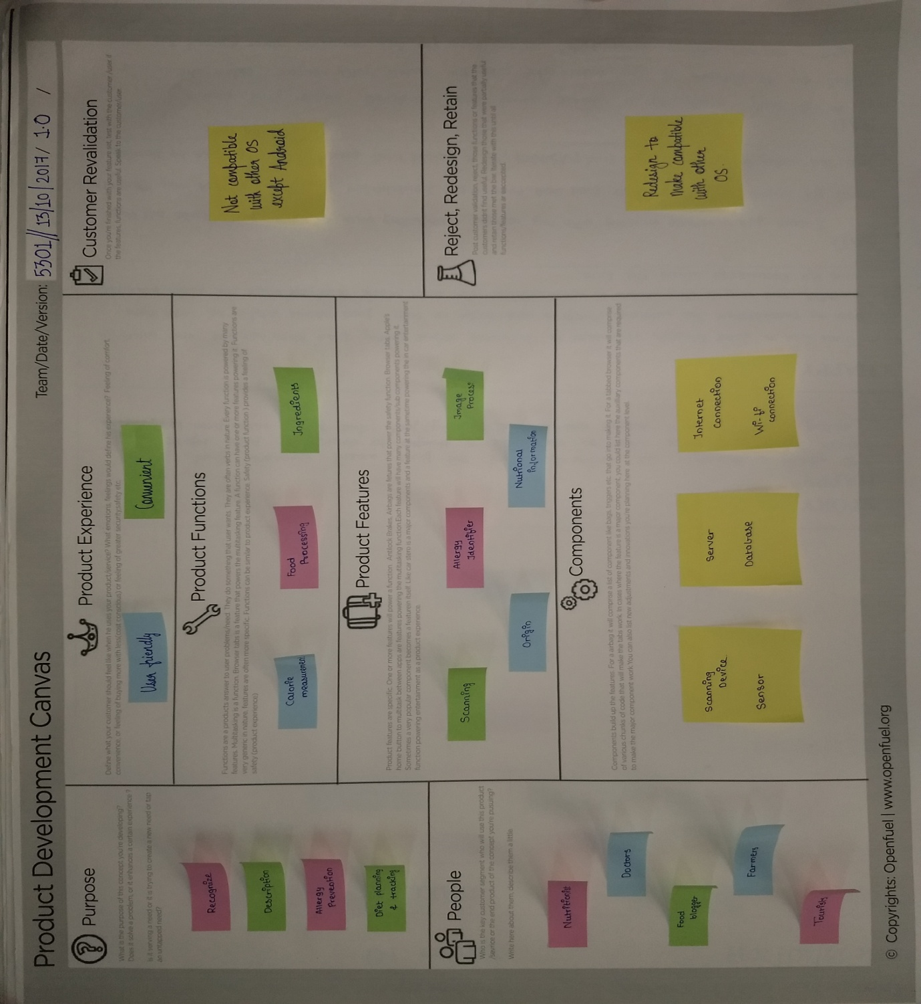

This canvas shows the purpose of food scanner,people, product functions of food scanner, components of food scanner.

**PURPOSE:**

* Food scanner is giving you the whole Description of particular scanning food.
* Food scanner helps you to Recognizing food.

**PEOPLE:**

* Nutrition
* Doctors
* Food blogger
* Tourists
* Farmers

**PRODUCTION FUNCTIONS:**

* Food processing
* Ingredients
* Calorie measurement

**PRODUCT FEATURES**:

* Scanning
* Image processing
* Origin
* Nutrition information
* Allergy identifier

**6. MIND MAPPING**

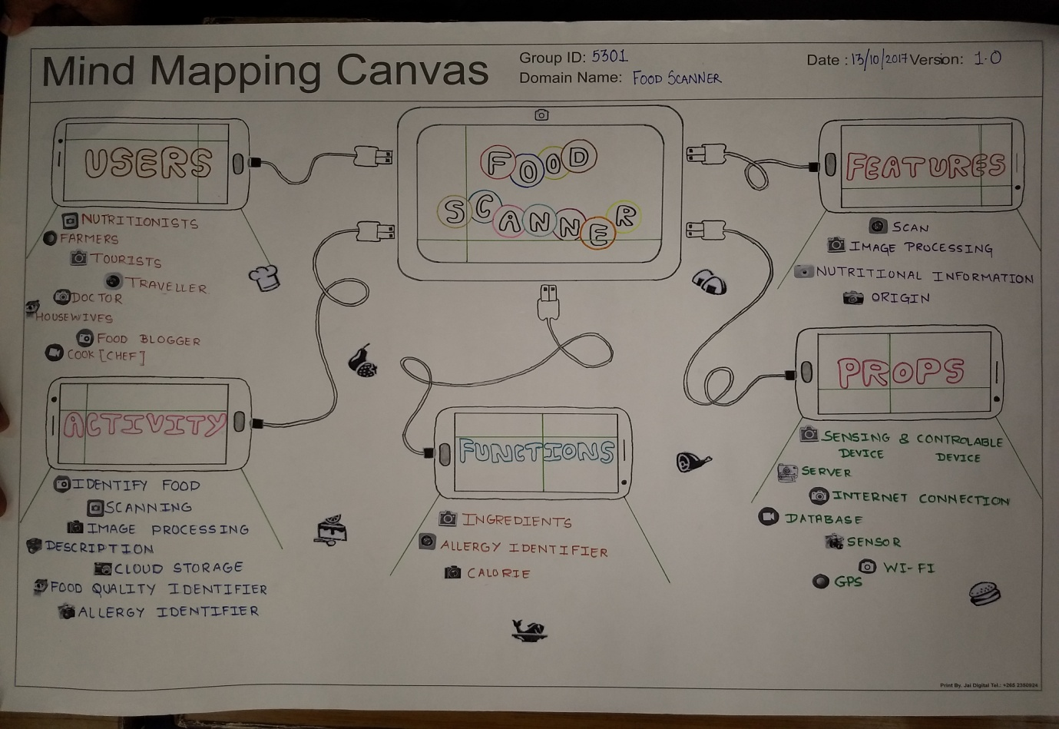

Here we can see the 5 features of food scanner in mind mapping.

* Users
* Props
* Activity
* Functions
* Features